Hugh Brennan
CITP 190
Project 3

Screen Capture for Project 3-1

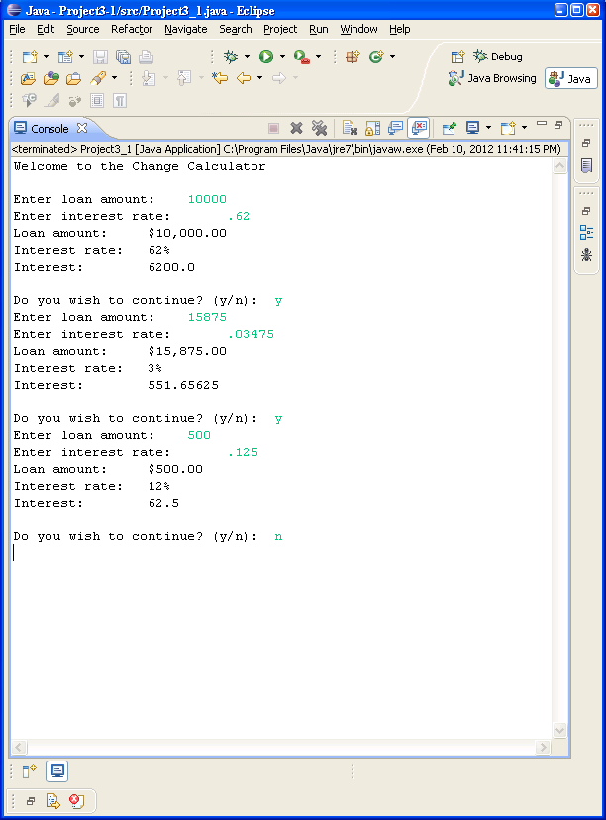

Screen Capture for Project 3-2

Welcome to the Interest Calculator

Enter number of cents (0-99):

1
Quarters: 0
Dimes: = 0
Nickels: = 0
Pennies: = 1
Do you wish to continue? (y/n): y
Enter number of cents (0-99):

3
Quarters: 0
Dimes: = 0
Nickels: = 0
Pennies: = 3
Do you wish to continue? (y/n): y
Enter number of cents (0-99):

4
Quarters: 0
Dimes: = 0
Nickels: = 0
Pennies: = 4
Do you wish to continue? (y/n): y
Enter number of cents (0-99):

5
Quarters: 0
Dimes: = 0
Nickels: = 1
Pennies: = 0
Do you wish to continue? (y/n): y
Enter number of cents (0-99):

6
Quarters: 0
Dimes: = 0
Nickels: = 1
Pennies: = 1
Do you wish to continue? (y/n): y
Enter number of cents (0-99):

9
Quarters: 0
Dimes: = 0
Nickels: = 1
Pennies: = 4
Do you wish to continue? (y/n): y
Enter number of cents (0-99):

10
Quarters: 0
Dimes: = 1
Nickels: = 0
Pennies: = 0
Do you wish to continue? (y/n): y
Enter number of cents (0-99):

50
Quarters: 2
Dimes: = 0
Nickels: = 0
Pennies: = 0
Do you wish to continue? (y/n): y
Enter number of cents (0-99):

51
Quarters: 2
Dimes: = 0
Nickels: = 0
Pennies: = 1
Do you wish to continue? (y/n): y
Enter number of cents (0-99):

75
Quarters: 3
Dimes: = 0
Nickels: = 0
Pennies: = 0
Do you wish to continue? (y/n): y
Enter number of cents (0-99):

79
Quarters: 3
Dimes: = 0
Nickels: = 0
Pennies: = 4
Do you wish to continue? (y/n): y
Enter number of cents (0-99):

83
Quarters: 3
Dimes: = 0
Nickels: = 1
Pennies: = 3
Do you wish to continue? (y/n): y
Enter number of cents (0-99):

99
Quarters: 3
Dimes: = 2
Nickels: = 0
Pennies: = 4
Do you wish to continue? (y/n): y
Enter number of cents (0-99):

11
Quarters: 0
Dimes: = 1
Nickels: = 0
Pennies: = 1
Do you wish to continue? (y/n): y
Enter number of cents (0-99):

14
Quarters: 0
Dimes: = 1
Nickels: = 0
Pennies: = 4
Do you wish to continue? (y/n): y
Enter number of cents (0-99):

15
Quarters: 0
Dimes: = 1
Nickels: = 1
Pennies: = 0
Do you wish to continue? (y/n): y
Enter number of cents (0-99):

16
Quarters: 0
Dimes: = 1
Nickels: = 1
Pennies: = 1
Do you wish to continue? (y/n): y
Enter number of cents (0-99):

19
Quarters: 0
Dimes: = 1
Nickels: = 1
Pennies: = 4
Do you wish to continue? (y/n): y
Enter number of cents (0-99):

20
Quarters: 0
Dimes: = 2
Nickels: = 0
Pennies: = 0
Do you wish to continue? (y/n): y
Enter number of cents (0-99):

21
Quarters: 0
Dimes: = 2
Nickels: = 0
Pennies: = 1
Do you wish to continue? (y/n): y
Enter number of cents (0-99):

22
Quarters: 0
Dimes: = 2
Nickels: = 0
Pennies: = 2
Do you wish to continue? (y/n): y
Enter number of cents (0-99):

24
Quarters: 0
Dimes: = 2
Nickels: = 0
Pennies: = 4
Do you wish to continue? (y/n): y
Enter number of cents (0-99):

25
Quarters: 1
Dimes: = 0
Nickels: = 0
Pennies: = 0
Do you wish to continue? (y/n): y
Enter number of cents (0-99):

26
Quarters: 1
Dimes: = 0
Nickels: = 0
Pennies: = 1
Do you wish to continue? (y/n): y
Enter number of cents (0-99):

49
Quarters: 1
Dimes: = 2
Nickels: = 0
Pennies: = 4
Do you wish to continue? (y/n): n

